**GOVERNMENT DENTAL COLLEGE & HOSPITAL, KADAPA.**

**DEPARTMENT OF PERIODONTICS**



**SEMINAR PRESENTATION ON “BIOMARKERS IN PERIODONTAL DISEASES”**

GUIDED BY: PRESENTED BY:

DR.P.SURESH, DR.K.LATHA,

PROF & HOD, PG STUDENT.

DEPT. OF PERIODONTICS.

**CONTENTS**:

* INTRODUCTION
* DEFINITION
* PERIODONTAL BIOLOGIC MARKERS IN THE GINGIVAL CREVICULAR FLUID
* SALIVA AS A SOURCE OF BIOMARKERS FOR PERIODONTITIS
* FUTURE DIRECTIONS FOR ORAL FLUID BIOMARKERS
* CONCLUSION
* REFERENCES

**INTRODUCTION:**

Periodontitis is an immune inflammatory response which arises from the interaction between the periodonto-pathogenic bacteria and host. The course of periodontal disease is marked by discontinuous pattern of disease activity and inactivity showing exacerbation and remission. The traditional clinical assessment methods include attachment level, probing depth, bleeding on probing, radiographic assessment of alveolar bone loss, but they neither provide information on the measures of disease activity nor do they identify the individuals who are susceptible to future disease progression as the biologic phenotypes are not reflected properly in the clinical phenotype. Biological phenotypes may then be taken into consideration which will be of help in assessing the burden of microbial and inflammatory load, which further affects the progression of periodontitis. Earlier the disease is diagnosed, more likely it is to be cured successfully.

Periodontal disease is time consuming and expensive to treat, hence prevention, early detection and management yield considerable health-care benefit. The application of scientific evidence and patient-specific information is now considered to be central to effective clinical management of periodontitis (Kwok, Caton, Polson, & Hunter, 2012).

It would be highly desirable to develop reliable, innovative, simple and non-invasive diagnostic methods for early detection of active disease status and for monitoring the response to periodontal therapy (Giannobile et al., 2009).

Early detection of disease plays a crucial role in successful therapy, thus, researchers are devoted to searching for diagnostic biomarkers with high sensitivity and specificity whereby periodontal risk can be identified before extensive clinical damage has occurred (Loos & Tjoa, 2005).

Biomarkers indicate health, disease, and/or response to therapy and must also be robust and proven valid in clinical studies. One of the main challenges in the field of periodontology is to discover an ideal periodontal diagnostic/prognostic biomarker which should be able to identify current disease activity, to differentiate active sites from inactive ones, to predict further disease progression and lastly to monitor the response to periodontal therapy (Buduneli & Kinane, 2011; Slots, 2013).

The biological media for detecting periodontal disease biomarkers included; gingival crevicular fluid (GCF), saliva, serum, subgingival plaque and tissue biopsies. They are particularly promising due to their ease of collection and consist of both locally synthesized and systemically derived molecules.

The ideal diagnostic test should be:

1. Highly specific, sensitive, reproducible and quantitative.

2. Simple to perform, rapid, one-stage or a two-stage procedure.

3. Non-invasive.

4. Versatile in terms of sample handling, storage and transport.

5. Amenable to chair-side use.

6. Economical.

**DEFINITION:**

Biomarkers were defined as “cellular, biochemical, molecular, or genetic alterations by which a normal, abnormal, or simply biologic process can be recognized or monitored” by the biomarkers definitions working Group (2001).

**PERIODONTAL BIOLOGIC MARKERS IN THE GINGIVAL CREVICULAR FLUID:**

GCF is a simple noninvasive approach to access the periodontium that currently plays a significant role in periodontal research. Analysis of GCF has extremely improved our understanding of periodontal pathogenesis and healing outcomes following treatment which plays a significant role in periodontal research in the years to come. The major attraction of GCF as a source of biologic markers is the site-specific nature of the sample, containing a vast array of host-derived molecules which represent relevant risk indicators of disease activity (Wassall & Preshaw, 2016).

As reviewed by Chapple (2009), host-derived biomarkers in GCF including; alkaline phosphatase, beta-glucoronidase, and cathepsin B demonstrated > 77% of diagnostic accuracy in predicting future periodontal disease activity. Moreover, MMPs-8 and −9, neutrophil elastase and dipeptidyl peptidases were correlated with the identification and activity of periodontal disease (Loos & Tjoa, 2005; Chapple, 2009).

GCF biomarkers include; inflammatory mediators, markers of oxidative stress, host-derived enzymes, tissue-breakdown products, mediators of bone homeostasis and growth factors.

I. **Inflammatory mediators:**

a) **Cytokines and chemokines:**

Numerous studies suggested that interleukin-1beta (IL1β), IL-2, IL-6, IL-8, IL-17 and tumor necrosis factor-alpha (TNF-α) in GCF are reliable inflammatory biomarkers in patients with different periodontal diseases (Teles et al., 2010; Rescala et al., 2010 Rescala, Teles, Fischer, Haffajee, & Socransky, 2010; Becerik, Ozturk, Atmaca, Atilla, & Emingil, 2012; Shaker & Ghallab, 2012) and decreased markedly after scaling and root planing (Cifcibasi et al., 2015; de Lima Oliveira et al., 2012).

One of the most studied biomarkers in the GCF is IL-1β, it is a potent bone-resorbing cytokine formerly known as the osteoclast-activating factor. Previous reports demonstrated that GCF IL-1β was elevated in active sites of periodontal disease and declined after periodontal therapy and thus can be used as a laboratory tool for assessing the activity of periodontal disease (Toker, Poyraz, & Eren, 2008; Oh et al., 2015 Oh, Hirano, Takai, & Ogata, 2015). In support with these reports, Nazar Majeed, Philip, Alabsi, Pushparajan, and Swaminathan (2016) concluded in their systematic review that IL-1β can be considered one of the most common biomarkers that give precise results which could be utilized as an indicator of periodontal disease progression.

Monocyte chemoattractant protein-1 (MCP-1) is one of the most important chemokines that causes recruitment of inflammatory cells and are thus involved in periodontal destruction. Previous investigations showed that MCP-1 and MCP-4 in GCF and saliva increased progressively with the progression of periodontal disease and decreased after treatment, hence can be proposed as potential biomarkers of disease severity (Gupta et al., 2013 Gupta, Chaturvedi, & Jain, 2013; Kumari, Pradeep, Priyanka, Kalra, & Naik, 2014).

Pentraxin-3 is another inflammatory mediator involved in acute-phase reaction, which has been proposed as a ‘marker of inflammatory activity in periodontal disease’ in the GCF (Kathariya et al., 2013; Pradeep, Kathariya, Raghavendra, & Sharma, 2011).

b) **Adipokines:**

To date, a growing number of adipokines have been evaluated as periodontal disease-specific biomarkers including; visfatin, leptin, adiponectin and resistin.

Most recently, Akram et al. (2017) concluded in their systematic review that resistin modulates inflammation and may be used as a surrogate measure to identify subjects at risk for chronic periodontitis. Consistent findings were previously reported showing that the increased level of resistin in the GCF can be regarded as potential inflammatory marker for periodontitis (Gokhale et al., 2014).

Other recent adipokines have been investigated in the GCF as progranulin (Priyanka et al., 2013), vaspin (Doğan, Ongoz Dede, Balli, & Sertoglu, 2016a) and chemerin (Doğan, Balli, Dede, Sertoglu, & Tazegul, 2016b) which were also considered as novel diagnostic and prognostic biomarkers for periodontal disease.

II. **Host-derived enzymes:**

Matrix metalloproteinases (MMPs) and tissue inhibitor of matrix metalloproteinases (TIMPs) are a family of proteinases involved in collagen degradation during periodontal tissue destruction (Sorsa et al., 2016). MMP-8 levels in GCF have been under investigation by various researchers. The analysis of MMP-8 in the GCF has proven to be a sensitive and specific unbiased biomarker for rapid chair-side that aids in early detection of periodontitis and may provide a useful tool in monitoring periodontal disease progression (Romero et al., 2013 Romero, Mastromatteo-Alberga, Escalona, & Correnti, 2013; Leppilahti et al., 2014; Sorsa et al., 2016). Other MMPs have also been investigated including MMP-3, MMP-13, and TIMP-1. GCF levels of these biomarkers significantly increased in periodontally active sites and thus were considered to have a role in diagnosing disease severity (Hernandez, Martinez, Tejerina, Valenzuela, & Gamonal, 2007; Pawar & Mehta, 2015).

In a longitudinal cohort study over a 12-month period, Kinney et al. (2014) assessed a panel of GCF biomarkers including MMP-8, MMP-9, osteoprotegerin (OPG) and IL-1β and reported significantly elevated levels with high sensitivity in patients showing periodontal disease progression. Recently, Baeza et al. (2016) also observed high diagnostic accuracies for ProMMP-2, ProMMP-9, and MMP-8 in chronic periodontitis.

Further host-derived enzymes investigated in the GCF comprise; alkaline phosphatase (Kunjappu, Mathew, Hegde, Kashyap, & Hosadurga, 2012) and myeloperoxidase (Leppilahti et al., 2014) which might also be used as biochemical markers for the detection and progression of periodontal disease. Another report suggested that increased concentrations of GCF-cathepsin K, a highly expressed cysteine protease, can be considered as a ‘marker of osteoclastic activity' in periodontal disease (Garg, Pradeep, & Thorat, 2009).

III. **Markers of oxidative stress:**

A large body of evidence shows that oxidative stress defined by an excess of reactive oxygen species and depletion of antioxidant levels in GCF lie at the heart of periodontal tissue destruction (Chapple & Matthews, 2007). Numerous studies evaluated markers of oxidative stress in GCF of patients with chronic periodontitis (Wei, Zhang, Wang, Yang, & Chen, 2010; Esen et al., 2012; Ghallab, Hamdy, & Shaker, 2016) and observed that non-surgical periodontal therapy significantly improved the redox balance in these patients (Dede, Ozden, & Avci, 2013; Hendek et al., 2015 Hendek, Erdemir, Kisa, & Ozcan, 2015).

Lately melatonin has received considerable attention because of its antioxidant, anti-inflammatory and immune enhancing properties (Gomez-Moreno, Guardia, Ferrera, Cutando, & Reiter, 2010). Few studies showed that as the degree of periodontal disease increased, GCF melatonin levels decreased (Srinath, Acharya, & Thakur, 2010; Almughrabi, Marzouk, Hasanato, & Shafik, 2013). Recently, consistent findings reported that melatonin might be considered a useful biomarker for monitoring the severity of periodontal disease and that oxidative stress GCF biomarkers could also be used to differentiate between patients with chronic and aggressive periodontitis (Ghallab et al., 2016).

IV. **Markers of bone homeostasis:**

Pyridinoline cross-linked carboxyterminal telopeptide of type I collagen, receptor activator of nuclear factor-κB-ligand (RANK-L), OPG and osteopontin are among the most common studied biomarkers of bone homeostasis in the GCF. These are biochemical markers specific for bone resorption, thus represent a potentially valuable diagnostic aid which may be useful in differentiating gingivitis from active periodontal bone destruction (Sharma & Pradeep, 2007; Becerik, Afacan, Ozturk, Atmaca, & Emingil, 2011). The levels of RANK-L and OPG were examined by many investigators, where the ratio of RANK-L/OPG had a consistent tendency to increase from periodontal health to periodontitis and to decrease after non-surgical periodontal therapy (Bostanci et al., 2007; Gumus et al., 2013; Hassan, El-Refai, Ghallab, Kasem, & Shaker, 2015). Based on these studies, RANKL/OPG ratio showed promise as a discloser of periodontal disease activity.

V. **Tissue-breakdown products:**

Cell adhesion molecules are cell surface proteins involved in the binding of cells to each other, to endothelial cells, or to the extracellular matrix. Changes reported in the levels of cell adhesion molecules in patients with periodontitis may be a sensitive indicator to differentiate healthy sites from those with periodontitis. Accordingly, these soluble adhesion molecules might be useful markers for monitoring periodontal wound healing and for the identification of periodontal disease progression (Chaturvedi, Gupta, Jain, Das, & Prashar, 2015).

Moreover, calprotectin is a major cytosol protein of leukocytes which has been thought to be a marker of inflammatory disease. Previous data indicated elevated calprotectin levels in GCF of both chronic and aggressive periodontitis, suggesting that it might be a useful diagnostic biomarker for evaluating the extent of periodontal inflammation, predicting disease activity and monitoring periodontal treatment (Becerik et al., 2011).

Recently, periostin was discovered as protein highly expressed in periosteum and periodontal ligament that might have a protective role against periodontal disease. Levels of periostin in GCF and saliva may be used as a possible biomarker to evaluate the outcome following nonsurgical periodontal therapy in patients with chronic periodontitis (Kumaresan, Balasundaram, Naik, & Appukuttan, 2016) may have a promising diagnostic potential for the aggressive forms of periodontal disease (Aral, Koseoglu, Saglam, Pekbagriyanik, & Savran, 2016).

VI. **Growth Factors**

Growth factors have also been investigated in GCF in relation to periodontal disease. It has been suggested that changes in the GCF levels of transforming growth factor-beta might be useful for monitoring the progress of periodontal repair and regeneration (Kuru, Griffiths, Petrie, & Olsen, 2004) and may as well predict the progression of periodontitis (Khalaf, Lonn, & Bengtsson, 2014). Similarly, vascular endothelial growth factor has attracted attention as a potential inducer of angiogenesis that could be considered as a biomarker of periodontal disease progression (Sakallioglu, Sakallioglu, Lutfioglu, Pamuk, & Kantarci, 2015). Furthermore, hepatocyte growth factor was proposed to play an important role in the progression of periodontitis by stimulating growth of epithelial cells and preventing regeneration of the connective tissue attachment, thus might be regarded as another biomarker for periodontal disease activity (Anil et al., 2014).

**SALIVA AS A SOURCE OF BIOMARKERS FOR PERIODONTITIS**

Saliva contains a highly enriched content of proteins, genetic molecules and locally and systemically derived biomarkers of periodontal disease that can be analyzed. Various biomarkers in saliva have been proposed which reveal a promising outlook for saliva as a key diagnostic medium for determining periodontal disease. Numerous reviews have shown that potential salivary biomarkers can provide important complimentary diagnostic information and can be used as tests for screening diagnosis, prognosis and predicting periodontal disease progression (Kaufman & Lamster 2000; Zhang et al., 2009; Giannobile et al., 2009; Nomura et al., 2012; Jaedicke et al., 2016; Korte & Kinney, 2016;). However, few studies have longitudinally monitored salivary biomarker profiles in patients with respect to periodontal status or determined if salivary biomarkers accurately represent periodontal disease status over time (Thomas et al., 2009).

Matrix metalloprotinase-8 is regarded as one of the promising candidates for diagnosing and predicting the progression of periodontal disease in saliva (Zhang et al., 2009). Elevated levels of salivary MMP-8 have repeatedly demonstrated significant positive correlations with periodontal clinical parameters in several studies (Miller, Langub, Kryscio, & Thomas, 2006; Ramseier et al., 2009; Costa et al., 2010; Gursoy et al., 2010; Kinney et al., 2011;). Moreover, significant reductions in salivary MMP-8 levels have been found after non-surgical periodontal therapy, suggesting their potential ability to monitor periodontal disease activity (Sexton, Lin, Kryscio, Ebersole, & Miller, 2011). Furthermore, a portable diagnostic hand-held point-of care-device, measured the oral fluid MMP-8 concentrations which were significantly elevated in periodontitis patients and decreased after scaling and root planing (Herr et al., 2007).

Similar diagnostic power has also been demonstrated for pro-inflammatory cytokines which mediate osteoclastogenesis and bone breakdown, such as IL-1β, IL-6 and TNF-α. Significantly elevated levels of these markers were observed in active periodontal disease sites (Miller et al., 2006; Costa et al., 2010; Gursoy et al., 2011) and also decreased after periodontal treatment (Sexton et al., 2011), therefore, they might serve as biomarkers of periodontitis.

Advances in technologies allowed researchers to identify potential panels of combined salivary biomarkers and periodontal pathogens which are more robust in distinguishing patients with periodontitis from healthy individuals as well as predicting future disease progression and stability. Ramseier et al. (2009) observed that differences in periodontal disease severity were efficiently detected by a combination of MMP-8, −9, OPG and calprotectin assays coupled with quantification of red complex bacteria in dental plaque. Sexton et al. (2011) also examined salivary biomarkers involved in inflammation, connective tissue degradation and alveolar bone turnover and revealed that MMP8, OPG, macrophage inflammatory protein-1 alpha, IL-1β, IL-8 and TNF-α reflected disease severity. Moreover, MMP-8 was the stand out as the best biomarker indicative of response to therapy. While Kinney et al. (2011), demonstrated that MMP-8, −9, OPG and IL-1β in low concentrations, successfully predicted periodontal stability. Another novel diagnostic approach revealed that the combinatorial ability of Porphyromonos gingivalis, IL-1β and MMP-8 altogether were able to detect periodontitis more accurately than each marker alone (Gursoy et al., 2011).

In a review, Jaedicke et al. (2016) concluded that IL-1β and hepatocyte growth factor are the most robust salivary biomarkers for periodontal disease studied up until now. Nevertheless, analysis of multiple salivary cytokines has shown inconsistent evidence regarding a ‘biomarker signature’. Therefore, high-quality research designs targeting sensitivity and specificity are mandatory to evaluate if the salivary biomarker can be utilized as a diagnostic test for early detection of periodontitis.

On the other hand, salivary markers of oxidative stress are widely debated as a probable tool for periodontal diagnostics. Oxidative stress markers have been extensively studied and found to be biomarkers of disease activity (Baltacioglu et al., 2014; Banasova et al., 2015; VillaCorrea, Isaza-Guzman, & Tobon-Arroyave, 2015). Novakovic et al. (2014) further stated that non-surgical periodontal therapy affected total antioxidant capacity in saliva. The local involvement of melatonin in the pathogenesis of periodontitis due to its antioxidant abilities, left it proposed as a salivary risk indicator for the severity of periodontal disease (Sirnath et al., 2010; Almughrabi et al., 2013). Salivary melatonin levels were also recovered after periodontal therapy and correlated with a decrease of local periodontal inflammation (Bertl et al., 2013).

In addition, other biomarkers as alkaline phosphatase, aspartate aminotransferase, RANKL/OPG, visfatin, chemerin and soluble CD44 (a cell surface adhesion molecule that mediates neutrophil adhesion and transendothelial migration) have been identified in the saliva and their elevated concentrations were associated with periodontal destruction.

In a systemic review, Seven studies were included in the review. Macrophage inflammatory protein-1αlpha (MIP-1α), interleukin-1beta (IL-1β), interleukin-6 (IL-6) and matrix metalloproteinase-8 (MMP-8) were identified as diagnostically acceptable biomarkers for periodontal disease. Overall, the combination of IL-6 and MMP-8 showed best diagnostic performance. Also, a combination of the four key biomarkers (IL-1β, IL-6, MMP-8 and MIP-1α) showed promising results for distinction between gingivitis and periodontitis, as well as for periodontitis compared with gingival health. Results are interpreted with caution due to limitations in the number of studies included and their quality.

**FUTURE DIRECTIONS FOR ORAL FLUID BIOMARKERS**

**Personalized medicine in periodontics**

Personalized medicine is a medical model that uses genetic, genomic, environmental and clinical diagnostic testing to individualize patient care. A combined analysis is required to identify the set of biomarkers with the most favorable combination of sensitivity, specificity, reproducibility and correlations with established disease diagnostic criteria. Utilization of this model in oral health care, specifically in periodontology, has the potential to provide discriminating patientstratification models to develop highly individualized diagnosis, prognosis and personalized treatment (Giannobile, 2012). Personalized medicine for periodontal diseases using saliva will be soon developed to make proper clinical decisions regarding disease susceptibility, sitespecific risk of disease progression and treatment modalities (Giannobile, Kornman, & Williams, 2013). The future is bright for the use of rapid, easy-to-use diagnostics providing an enhanced patient assessment that will allow oral health-care providers to improve prevention and treatment of periodontal diseases (Miller et al., 2010; Korte & Kinney, 2016).

**Point-of-care diagnostics**

Point-of-care (POC) diagnostics is defined as a medical testing that is not performed in a laboratory, yet at the patient’s home, or the doctor’s office. Optimally, such tests should be available in the form of chair-side or home-use dip-stick tests. By a POC device using saliva patients could easily diagnose periodontitis at home and visit their periodontist accordingly (Ji & Choi, 2015). These self-performed tests should accelerate clinical decision-making and monitoring of periodontal disease progression (Kaufman & Lamster, 2000).

In the field of periodontal diagnostics, recent developments in POC testing with new technologies have advanced significantly for the future use of oral fluids allowing accurate, rapid chair-side testing and enhance individualized care. Hereafter, researchers have been searching for explicit markers of periodontitis in saliva and GCF for the development of adjunctive, non-invasive, novel technologies (Christodoulides et al., 2007; Miller et al., 2010; Giannobile, 2012). Currently, the activity MMP-8 lateral-flow POC immunotests is a recently developed commercially available mouth-rinse that is practical, convenient and inexpensive test that takes just 5 min that is used to detect, predict and monitor the course and treatment of periodontitis (Heikkinen et al., 2016; Rathnayake et al., 2017). This test is one of the new tests, that qualifies for a biomarker which could identify disease activity, predict progression and monitor response to periodontal therapy.

**Objectives of chair side tests**

1. They are minimally invasive, thus having an edge over conventional diagnostic aids.

2. Relatively less tedious to the patient as the appointment time is reduced.

3. Less cumbersome or technique sensitive, making them user friendly.

4. Help in early diagnosis and treatment planning.

5. Can be used as an encouragement tool to motivate the patient.

**METHODS OF ANALYSIS:**

Several methods have been employed to detect putative periodontopathogens in clinical samples. These include cultural methods, microscopy, immunofluorescent assays, enzyme-linked immunosorbent assays, trypsin-like protease assays, DNA probes and the PCR.

Among these tests, chairside periodontal kits provide immediate reports of the microflora associated with the disease compared to cumbersome and time-consuming traditional laboratory procedures. Chairside periodontal test kits can be categorized as

1. Microbiological test kits

2. Biochemical test kits

3. Genetic kits.

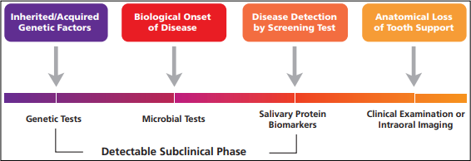

**Use of saliva in point of care diagnostics:**

Saliva offers many advantages as it is readily available, contains a rich array of diagnostic biomarker molecule, non-invasive method of sampling and ability to obtain rapid and reliable results. Saliva has also proved to be beneficial as compared to blood because it is easy to handle saliva as it does not clot and also chances of accidental transmission of infectious disease during its collection is less than blood samples. However, one of the major limitations of using saliva is that as compared to saliva and serum the informative analytes generally are present in lower amount therefore, assays need to be highly sensitive. The origin of saliva determines its composition and is influenced by various environmental and psychological stimuli. Thus, qualitative analysis of saliva markers can be reliably achieved but to quantify these markers is the real problem. Apart from these, presence of mucins and cell debris makes saliva a challenging fluid to work with.

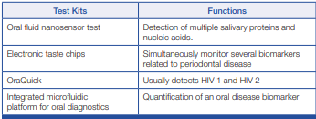

**BIOCHEMICAL TEST**

1. **Oral fluid nanosensor test:**

A new POC device to detect oral cancer in saliva was developed by the University of California, Los Angeles (UCLA) Collaborative Oral Fluid Diagnostic Research Laboratory, led by Dr. David Wong. This is an automated POC device that is designed for the electrochemical detection of multiple salivary proteins and nucleic acids. It is an ultrasensitive and ultraspecific micro electromechanical system which simultaneously and precisely detects these proteins and nucleic acid. The product is Oral Fluid Nano Sensor Test (OFNASET). Four salivary mRNA biomarkers (SAT, ODZ, IL-8 and IL-1b) and two salivary proteomic biomarkers (thioredoxin and IL-8) in saliva are detected in this system. The OFNASET is actually a screening device for detecting oral cancer.

1. **Electronic taste chips:**

Researchers at Rice University in Houston, Texas, are developing a lab-on-a-chip system, which will differentiate between healthy and periodontally diseased individuals based on the CRP levels. This microchip based detection system is used for measuring analytes (acids, bases, electrolytes and proteins) in solution phase. This novel system is called an Electronic Taste Chip (ETC). On the interior regions of the microspheres, sensor array platform is placed where all the chemical and immunological reactions are performed. These microspheres are located on the inverted pyramidal microchambers of microchip. A Charge-Coupled Device (CCD) video chip visualizes and captures the various optical signals generated by the reactions on the microspheres. The ETC system has the advantage over the ELISA in having porous beads, which allows greater number of antibody molecules to capture and thus detect, CRP at extremely low concentrations. In ELISA, antigen–antibody interactions are generated on a single layer at the bottom of the well.

1. **OraQuick:**

To expedite screening and accurately diagnose HIV infection, rapid POC HIV tests have been developed which provides results in 20 minutes. The fluid to be diagnosed is mixed in a vial with developing solution and the results are displayed on a testing device. It is a stick-like device with a fabric swab on one end which is inserted into a tube of testing fluid. OraQuick® is the first FDA-approved oral swab in-home test for HIV-1 and HIV-2.

1. **Integrated microfluidic platform for oral diagnostics (IMPOD):**

IMPOD, a POC diagnostic test, helps in the rapid quantification of salivary biomarkers related to oral disease. It facilitates hands-free saliva analysis by integrating sample pretreatment with electrophoretic immunoassays to quickly measure analyte concentrations in minimally pretreated saliva samples. Rapid measurement of levels of the collagen cleaving enzyme MMP-8 in saliva from healthy and periodontally diseased subjects can be achieved. The hand-held IMPOD has been used to rapidly (3–10 minutes) measure the concentrations of MMP-8 and other biomarkers in small amounts (10 ml) of saliva.

**MICROBIOLOGICAL TEST**

1. **My PerioPath:**

My PerioPath detects the pathogens causing periodontal disease in saliva samples. This test uses DNA polymerase chain reaction to detect the type and concentration of bacteria present in the salivary sample.

1. **Omnigene:**

OmniGene Diagnostics, Inc. are species specific DNA probes to identify eight pathogens which are known to cause periodontal disease, (Porphyromonas gingivalis, Prevotella intermedia, Aggregatibacter actinomycetem-comitans, Fusobacterium nucleatum, Eikenella corrodens, Campylobacter rectus, Bacteroides forsythus and Treponema denticola). The advantage of using these test kits is that the results are available in short period of time and can be mailed or faxed to the clinician. This is a microbiological test which detects microrganisms causing periodontitis like A. actinomycetemcomitans, P. gingivalis, T. forsythia and T. denticola using RNA probes in the sample collected.

Merits

1. Reports are provided within short periods of time, few hours to few days.

2. It helps in identification of number of known periodontal pathogen

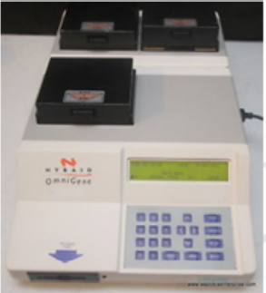

**GENETIC TEST**

1. **MyperioID:**

MyPerioID identifies the genetic susceptibility of the patient to periodontal diseases by using salivary samples which are shipped to the laboratory for the results. These test plays role in evaluating the patients which are at higher risk of periodontal destruction.

**USE OF GCF IN POINT OF CARE DIAGNOSTICS:**

GCF can be frequently used for biomarkers as it easily obtained from the oral cavity. Chapple I stated the advantages of using GCF: "The biomarkers found in GCF indicate the presence or absence of periodontal pathogens, gingival and periodontal inflammation, the host inflammatory-immune response to specific pathogenic species and host tissue destruction". The disadvantages of using GCF are that it requires multiple samples of individual tooth sites and extensive laboratory processing, thereby making it expensive and time consuming.

Although, GCF has several diagnostic advantages because of the appearance of inflammatory mediators and tissue-destructive molecules in it, the procedure of collection and analysis makes it difficult to be used as a chairside diagnostic medium. GCF collection is laborious and technically demanding requiring special equipment for calibrating and measuring fluid volumes. There is also a possibility of GCF being contaminated with blood, saliva, or plaque.

Biochemical Test

a. Periogard:

Aspartate aminotransferase (AST) which is released on cell death is the main enzyme that is detected by PerioGard. In periodontal diseases due to cell death there is elevated AST levels which act as a positive marker in active locations. The test contains two wells for each for tooth and the chemicals. But in practice, PerioGard assay is a relatively complex process which involves numerous steps and has difficulty in color measurement.

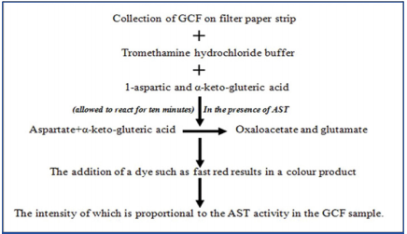

1. Perio watch:

The Pocket watch is a chairside test for analyzing AST levels. Principle: AST acts as catalyst in the exchange of an amino group of cysteine sulfuric acid by α- keto- gluteric acid to produce β-sulfinyl pyruvate in the presence of pyridoxal phosphate. Inorganic sulphite is released by the spontaneous decomposition of glutamate β-sulfinyl pyruvate. The sulfite ion thus produced reacts with Malachite Green (MG), which converts a green dye to its colorless form, thereby showing the pink–colored rhodamine B dye. The AST concentration can be assessed though the rate of conversion of MG.

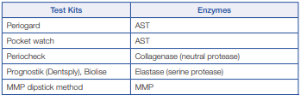

1. **Periocheck:**

Periocheck is a Food and Drug Administration (FDA) approved product. Periocheck is the most rapid chairside test for detecting neutral proteases in GCF like elastases, proteinases and collagenase, still it suffers from certain drawbacks like interproximal sites cannot be sampled due to saliva contamination, test is not specific for PMNL collagenase and may include enzymes of bacterial origin.

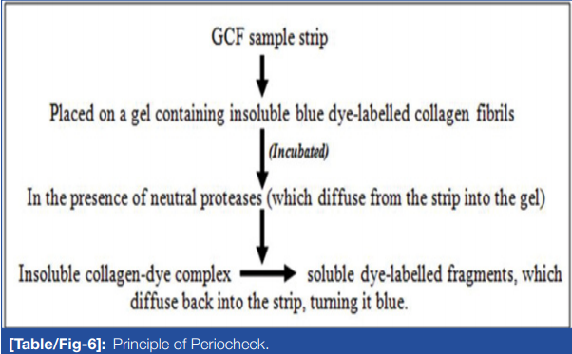

1. **Prognostik:**

Prognostik, developed in the year 1993, measures the levels of MMPs such as the elastases in the GCF. Active disease sites produce an elevated elastases level in the GCF as released from the lysosomes of polymorphonuclear leucocytes. However, further clinical trials are required to establish relationship between elastase levels in GCF and periodontal disease activity.

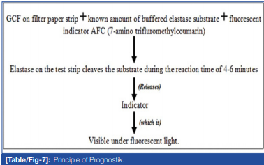

1. **MMP dipstick test:**

MMPs are host-derived proteinases which plays a major role in periodontitis and dental peri-implant health and diseases. This forms the basis for the development of both qualitative and quantitative chairside POC technologies which will help in the rapid detection of pathologically elevated levels of MMP-8 in oral fluids and serum. Monoclonal antibodies for MMP-8 are being utilized in chairside POC immunotests for oral fluid and serum MMP-8 analysis. The MMP-8 stick-test can differentiate healthy gingiva and gingivitis sites from periodontitis sites and the results obtained correlates with that of quantitative laboratory Immunofluorometric Assay (IFMA).

**Microbial test KITS**

A plethora of research activity had explored the role of plaque as a possible medium for detecting the periopathogens which is an important aspect in the diagnosis and treatment of periodontal diseases. Considerable newer developments have occurred in methods of detecting periodontopathogens in plaque sample.

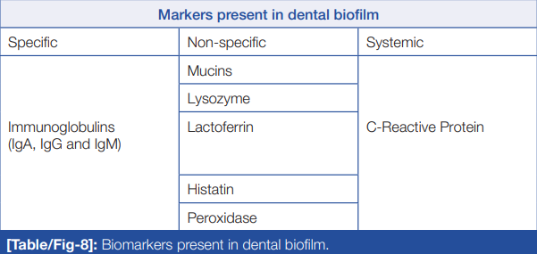

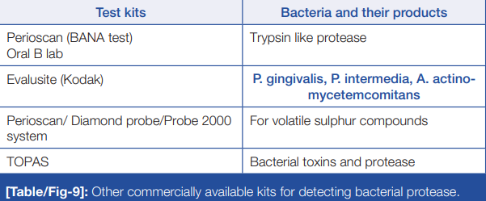

a. **Perioscan (BANA):**

P. gingivalis, T. denticola, T. forsythia and some Capnocytophaga strains produce bacterial trypsin-like proteases in the dental plaque which can be detected by Perioscan. The major drawbacks of this test being that it cannot identify the pathogens which produces non-trypsin like enzymes and its inability to differentiate the specific bacteria amongst the three producing these enzymes.

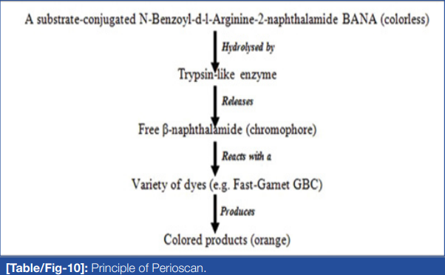

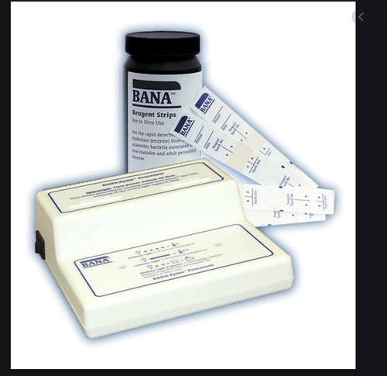

**Merits**

Used to identify volatile sulphur compounds in halitosis patients

**Demerits**

1. In this test, there is always a lack of quantitative data.

2. The specific bacteria that are responsible for enzyme production can’t be determined.

3. They cannot identify the presence of other pathogens that do not produce trypsin like enzyme.

4. The results are qualitative and rely upon the operator’s assessment at the calorimetric end point.

1. **Evalusite:**

Three putative periodontopathogens (Aa, Pg and Pi) can be detected using membrane-based enzyme immunoassay, Evalusite. Subjective assessment of the color is one of the major disadvantages of this test. Also, this assumption that the three bacteria detected are the only disease causing organisms limits it us.

**Merits**

It employes a normal membrane base enzyme immunoesaay for the detection of three putative periodonto pathogens. (Aa, Pg, Pi).

**Demerits**

1. It is multistage test.

2. It has a subjective calorimetric end point.

3. There is no permanent record of the result.

4. Gives the assumption that the three organisms are causing the disease.

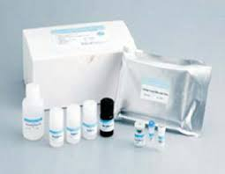

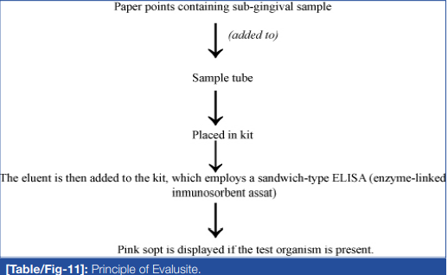

1. **Perio 2000:**

Degradation of serum proteins (cysteine and methionine) leads to Volatile Sulphide Compounds (VSCs) production by microorganisms like P. gingivalis, P. intermedia and T. forsythia. Evaluations of VSCs are indicative of subgingival microbial load as it plays role in degrading periodontal structures aggravating periodontitis. Perio 2000 system displays the sulphide level digitally at each site. Sterile wash solution is used to hydrate the tip then at peak or hold operational mode it is inserted subgingivally. After obtaining the reading, the tip is washed and reinserted in other subgingival site.

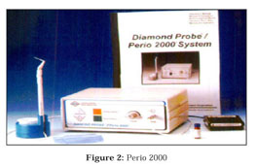

The system consists of:

1. Single use, disposable sensor tips that combine an updated standard Michigan "O" style dental probe with a sulfide sensor for use during one-time examinations

2. An electronic control unit that provides real-time visual feedback of bacterial activity to the practitioner and patient

3. Probe handle, hand-piece cable, foot switch, and external power supply

4. Wash solution

5. Accessory stand for convenient wash cup placement and temporary probe storage

6. System check

It can be used:

1. During initial patient screening as an adjunctive measurement of a patient's oral health status

2. During and after routine supportive periodontal therapy

3. At maintenance intervals

4. As a tool to provide patient education and motivation.

1. **Toxicity Prescreening Assay (TOPAS):**

TOPAS is a chairside test kit for indirectly detecting bacterial toxins and bacterial proteins which are one of the markers for the presence of gingival infection. The principle behind this test relies on the detection of actively dividing and growing pathogens which can be assessed through the metabolic activity of these organisms in the crevicular fluid. This test can be used to know difference between an active and an inactive periodontal disease as indicated by the change in the color intensity scale of the test based on the fact that metabolic activity increases as the concentrations of these toxins increases.

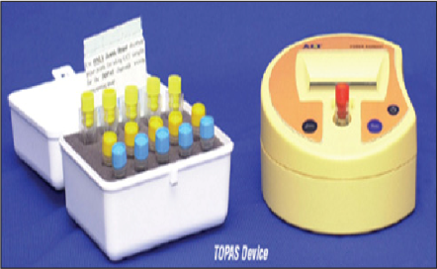

**GENETIC TEST**

The Periodontitis Susceptibility Trait test (PST) is the test which identifies the genetic predisposition of the patient for periodontitis by detecting the polymorphism in IL-1 gene. Polymorphism in two positions of IL-1 i.e position -889 and + 3953 has been associated with periodontal disease.

**ADVANTAGES OF POINT OF CARE**

POC testing eliminates the need to draw blood and reduces the cost and inventory associated with sample shipping and handling to a centralized laboratory thereby, reducing the total time involved and improves the quality of care delivered by allowing treatment to begin immediately. Periodontal oral POC diagnostic devices requires less training and fewer resources than current diagnostic tests, proving to be more effective, thereby enabling screening of large populations quickly. The benefit of screening various population is the identifying at-risk groups more effectively and increasing the access to treatment.

**DISADVANTAGES OF POINT OF CARE DIAGNOSTICS**

The use of POC diagnostics in the periodontal surveillance looks promising; however in the clinical setting, these approaches suffer from various obstacles. These new periodontal diagnostics needs to be validated and benchmarked with existing methods of disease evaluation (alveolar bone levels and clinical attachment levels). Acceptance of such methods by dentists and treatment clinicians is imperative and may prove to be difficult. Another issue to be addressed is the cost effectiveness of the procedure. Clinician needs to be abreast with the knowledge of diagnosis, disease risk and its prevention before diagnostics may be integrated into routine clinical periodontal practice.

**PROTEOME ANALYSIS**

Proteomics directly studies the proteins that are key functional components of biochemical systems and describes the large-scale study of the entire complement of proteins expressed by a genome and present in a cell, tissue, biofluids, or organism (Aebersold et al. 2000). The word “proteome” was introduced by Wilkins et al. (1996) as a combination of two words, “protein” and “genome”. The proteome is the protein complement of the genome and proteomics is the analysis of the portion of the genome that is expressed. The human proteome is estimated to contain more than 20,000 proteins, excluding possible isoforms. There are two strategies for proteomic applications: discovery (qualification) and quantification, mostly as the first and second step. After surface enhanced laser desorption/ ionisation-time-of-flight mass spectrometry was invented, mass spectral fingerprints of proteins were detected basing on their molecular weight rather than their sequence identity within the context of qualitative proteomics. This earlier technology was successfully applied to GCF proteome analysis, but solely it cannot reveal the identity of proteins or their functions. The advancement of analytical proteomic platforms came with the combined use of in-gel digestion along with their extensive separation and enhanced spectral analysis (Bostanci and Belibasakis 2018).

Later on, quantitative proteomics were applied to GCF samples. Proteomics has the potential to produce low-cost POC devices (Wignarajah et al. 2015; Koboniwa et  al. 2016). However, one of the major challenges in identification and quantification of the GCF or salivary proteome is the dynamic range of protein concentrations often spanning several orders of magnitude. There is a risk of being masked for the proteins that have the lowest relative amounts in the complex mixture.

Saliva has been used as a biofluid for proteomics analysis and more than 3000 proteins have been identified for disease (Zhang et  al. 2016). Moreover, evidence suggests that proteomics facilitate the identification of GCF biochemical markers in patients with periodontal disease (Bostanci et al. 2010; Bostanci and Bao 2017; Bostanci and Belibasakis 2018; Khurshid et al. 2017). Today, proteomics are used for discovering and identifying GCF biomarkers with matrix-assisted laser desorption/ionisation timeof-flight mass spectrometry (MALDI-TOF MS), liquid chromatography (LC) coupled with tandem mass spectrometry (MS/MS) (LC-MS/MS).

The proteomic analysis of GCF in different periodontal conditions demonstrates marked differences according to disease profile. Zelko, Mariani and Folz (2002) found a total of 327 GCF proteins in periodontally healthy individuals using a gel-free method that were analyzed directly by liquid chromatography–tandem, suggesting that they may be used as a reference in future proteomic studies on GCF biomarkers of periodontal disease. Later studies reported that up to 432 different proteins have been identified in GCF samples (Baliban et al., 2012; Silva-Boghossian et al., 2013). Considering that the protein composition of GCF might reflect the pathophysiology of periodontal disease progression, GCF protein profiles obtained from healthy-looking individuals may be explored as standard GCF proteomic patterns, which might serve as a reference for the identification of periodontal diseases biomarkers by proteomic analyses. However, further studies with larger sample sizes are needed to validate the role of the identified proteins in the pathogenesis of periodontal disease (Barros et al., 2016).

Searching for markers to predict health or disease, Bostanci et al. (2010) used quantitative proteomic analysis with liquid chromatography–mass spectrometry to analyze GCF samples and reported that GCF proteins cystatin-B and alpha defensin 1 were detected only in healthy samples, while L-plastin, a protein with a vital role in immunemediated events, was only detected in GCF of aggressive periodontitis patients.

A key advance in this area is the development of the salivary proteome knowledge base which is part of the human salivary proteome project. Salivomics is a developing branch which describes the study of biological molecules like the transcriptome, the proteome and the metabolome in saliva which will launch the personalized diagnostic approaches in dental clinics (Wong, 2012). The main advantages of salivary proteomics are that low levels of a specific biomarker can be detected. These handheld, automated and easy-to-use systems will enable rapid detection of salivary protein biomarkers that can be used for POC disease screening and detection (Haigh et al., 2010)

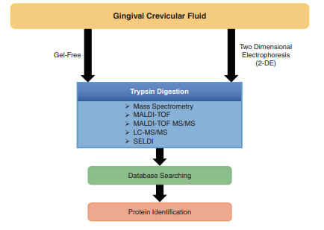

**CONCLUSION:**

**Unravelling the quantitative changes of host and bacteria-derived GCF proteins will improve the knowledge on GCF protein composition and clarify specific alterations occurring in protein content that may be used as biomarkers for periodontal disease. There is still a long way to go; however, technological developments together with the curiosity and passion of researchers will eventually make it come true! Particularly prospective biomarkers are highly required.**

**REFERENCES:**

* **Carranza’s clinical periodontology – 13th edition.**
* **Buduneli, Nurcan – biomarkers of periodontal health and disease.**
* **Ghallab N A, Diagnostic potential and future directions of biomarkers in gingival crevicular fluid and saliva of periodontal diseases: Review of the current evidence. Archives of Oral Biology 87 (2018) 115–124.**
* **Srivastava N, Nayak P A, Rana S, Point of Care- A Novel Approach to Periodontal Diagnosis-A Review. Journal of Clinical and Diagnostic Research. 2017 Aug, Vol-11(8): ZE01-ZE06.**
* **Chepuri T, Gooty J R, Durvasala S, Palaparthi R, Chair Side Diagnostic Test Kits in Periodontics. Indian J Dent Adv 2015; 7(1): 41-45.**
* **Giannonile W V, Salivary diagnostics for periodontal diseases. JADA 2012; 143(suppl 10): 6S – 11S.**
* **Pajnigara N G, Kolte A P, Kolte R A, Panjnigara N G, Chair side diagnostic kits in Periodontics. INTERNATIONAL DENTAL JOURNAL OF STUDENT’S RESEARCH, April 2016, Volume 4,Issue 1.**
* **Sukriti KC, Wang XZ, Gallagher JE. Diagnostic sensitivity and specificity of host-derived salivary biomarkers in periodontal disease amongst adults: Systematic review. J Clin Periodontol. 2020;47:289–308.**